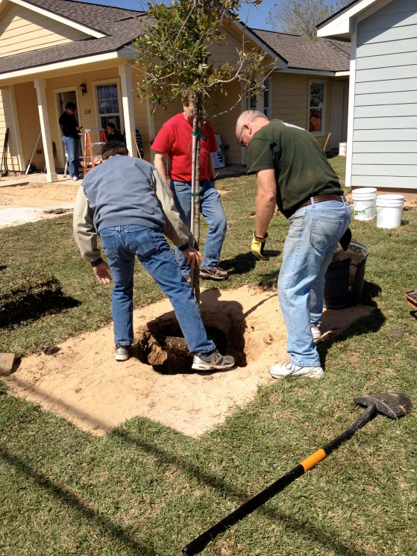
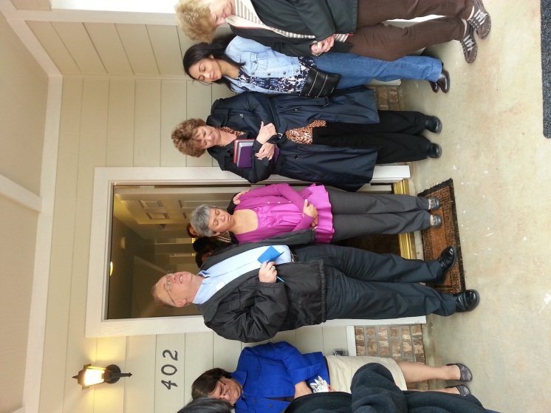
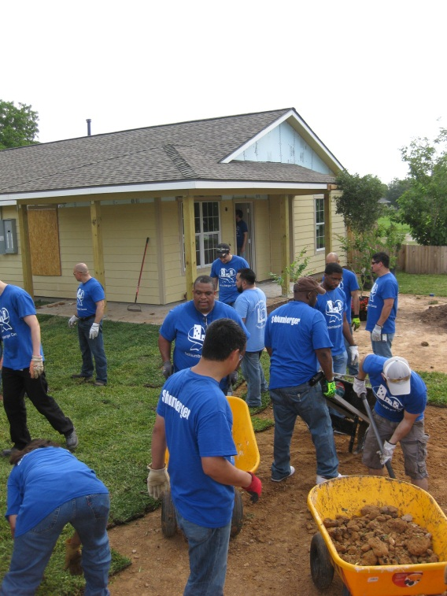
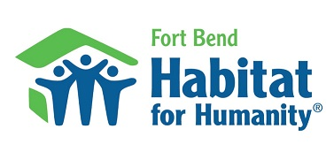
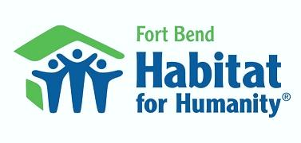
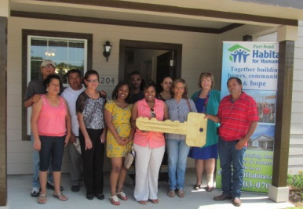
- Home Builder $70,000
- Dream Builder $35,000
- Cornerstone Builder $10,000
- Foundation Builder $5,000
*$70,000 will fund the construction of an entire Fort Bend Habitat for Humanity home
Home Builder
$70,000

Opportunities for Business Support
Building Homes, Communities, and Hope

Worksite Team-Building
- This is a rewarding experience for corporations as you are able to fund
the expenses for an entire Habitat
home for someone in need of decent, affordable housing.
- Your organization will be the exclusive house building team for all build days
Celebration of Partnership
- Your business logo and website link posted on the website for 1 year
- Permission to show our logo and link on your website if you wish
Worksite Signage
- Business name and logo
displayed at the Build Site
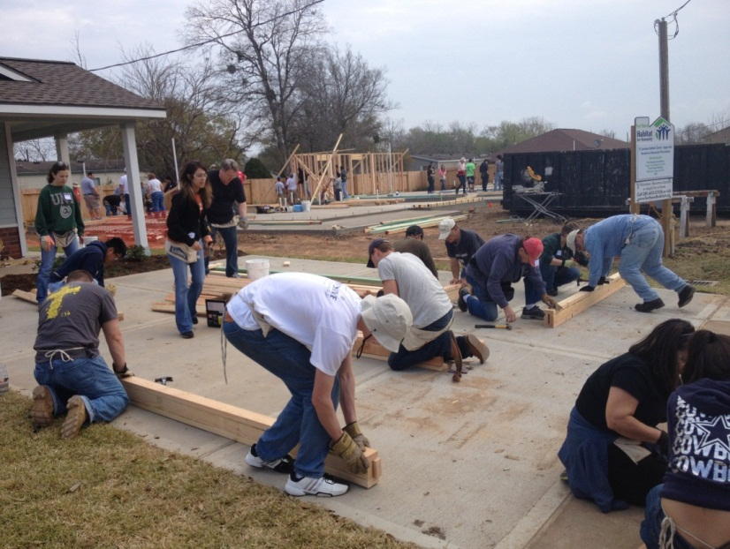

Recognition Plaque
- An engraved plaque for your office
Home Dedications
- Speaking opportunity at the dedication
- Business sponsorship verbally
recognized at the dedication
- Your business name and logo
listed in the event program
- Personal invitation to the dedication
News Releases
- Article about your dedication and sponsorship on our website and in our Habitat Newsletter
Habitat T-shirts
- Up to 100 customized Habitat t-shirts with both the Habitat logo and your company logo along with the project year

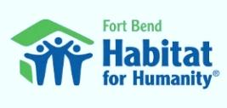
Dream Builder
$35,000
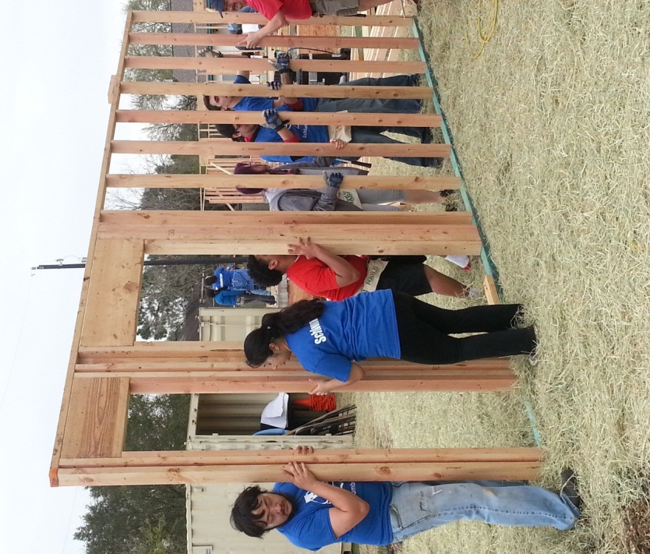
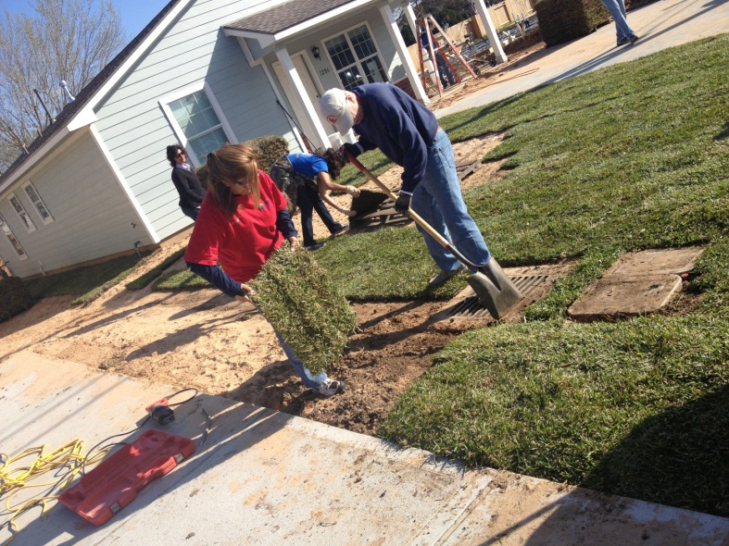
Worksite Team-Building
- This is a rewarding experience for corporations as you are able to fund the expenses for half of a Habitat home for someone in need of decent, affordable housing.
- Volunteers from your organization can serve as the exclusive house building team
Celebration of Partnership
- Your business logo and
website link posted on our
website for 6 months
- Permission to show our logo
and link on your website if you wish
Worksite Signage
- Business name and logo
displayed on the Build Site
Recognition Plaque
- An engraved plaque for your office
Home Dedications
- Speaking opportunity at the dedication
- Business sponsorship verbally
recognized at the dedication
- Your business name and logo
listed in the event program
- Personal invitation to the dedication
Habitat T-shirts
- Up to 50 customized Habitat t-shirts with both the Habitat logo, your company logo, and the project year

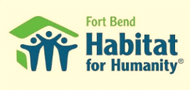
Cornerstone Builder
$10,000
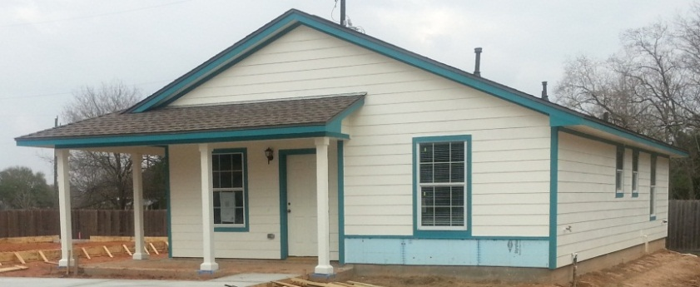
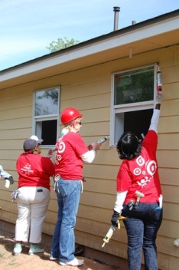
Worksite Team-Building
- This experience is a popular team-building opportunity.
- Volunteers (skilled or unskilled) from your organization can serve as the exclusive house building team
Celebration of Partnership
- Your business logo posted on the website for 1 month
Worksite Signage
- Business name displayed at the Build Site
Home Dedications
- Personal invitation to the dedication
- Business recognized at the dedication
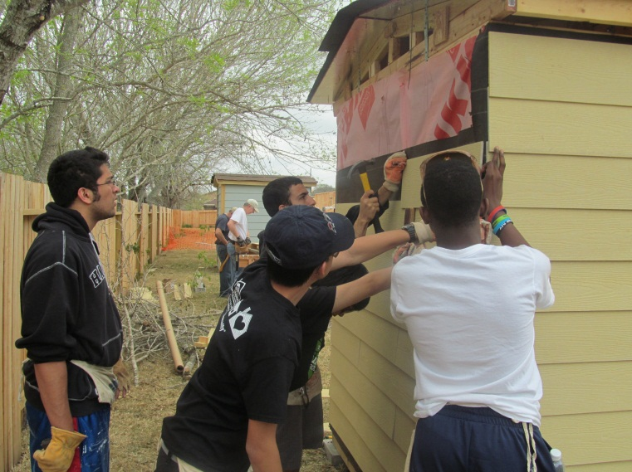
Foundation Builder
$5,000
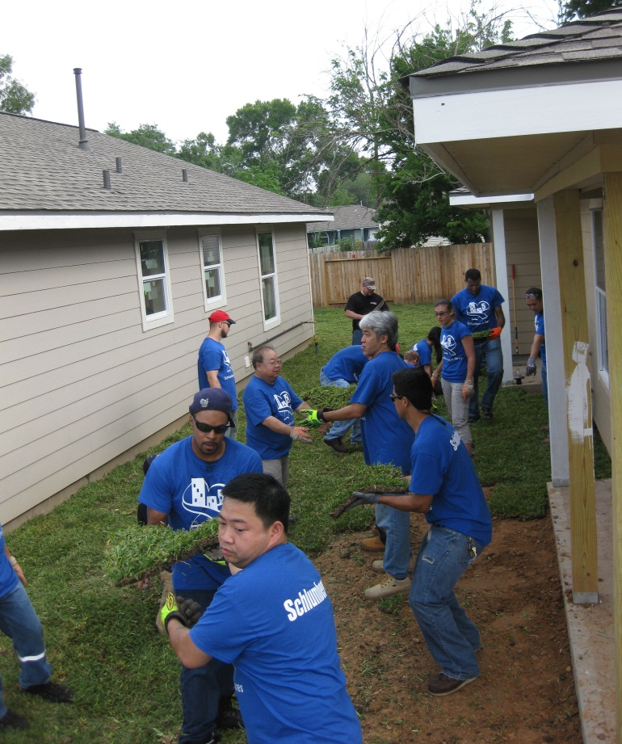
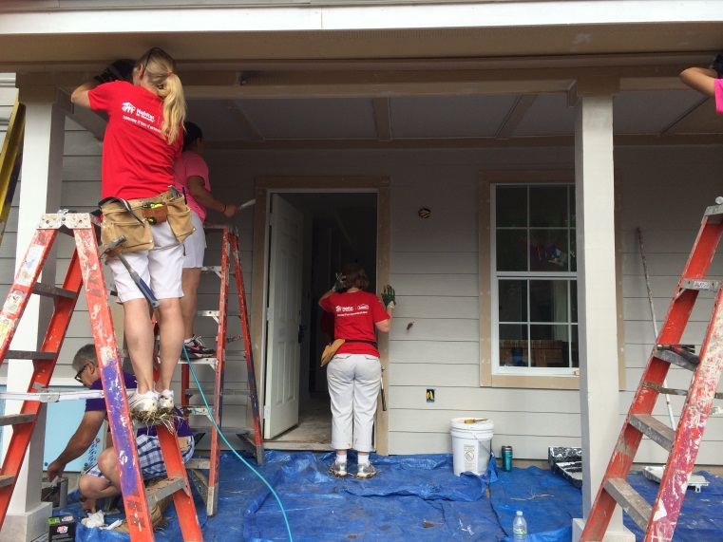
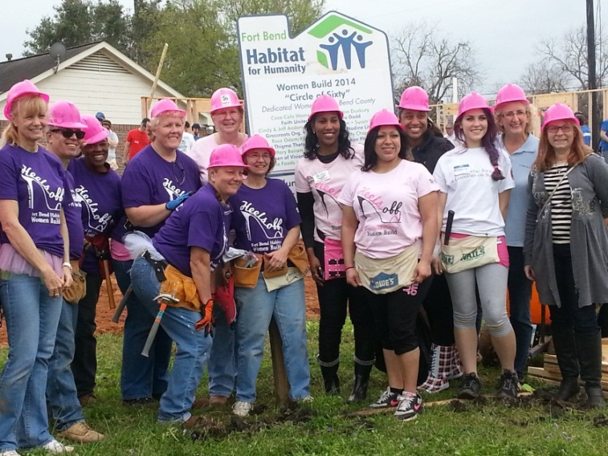
Worksite Team-Building
- This experience is a popular
team-building opportunity
- Your volunteers can join other
community volunteers on the project
Home Dedications
- Personal invitation to the dedication
Worksite Signage
- Business name displayed
at the Build Site
- Personal invitation to the dedication
Worksite Signage
- Business name displayed
at the Build Site

